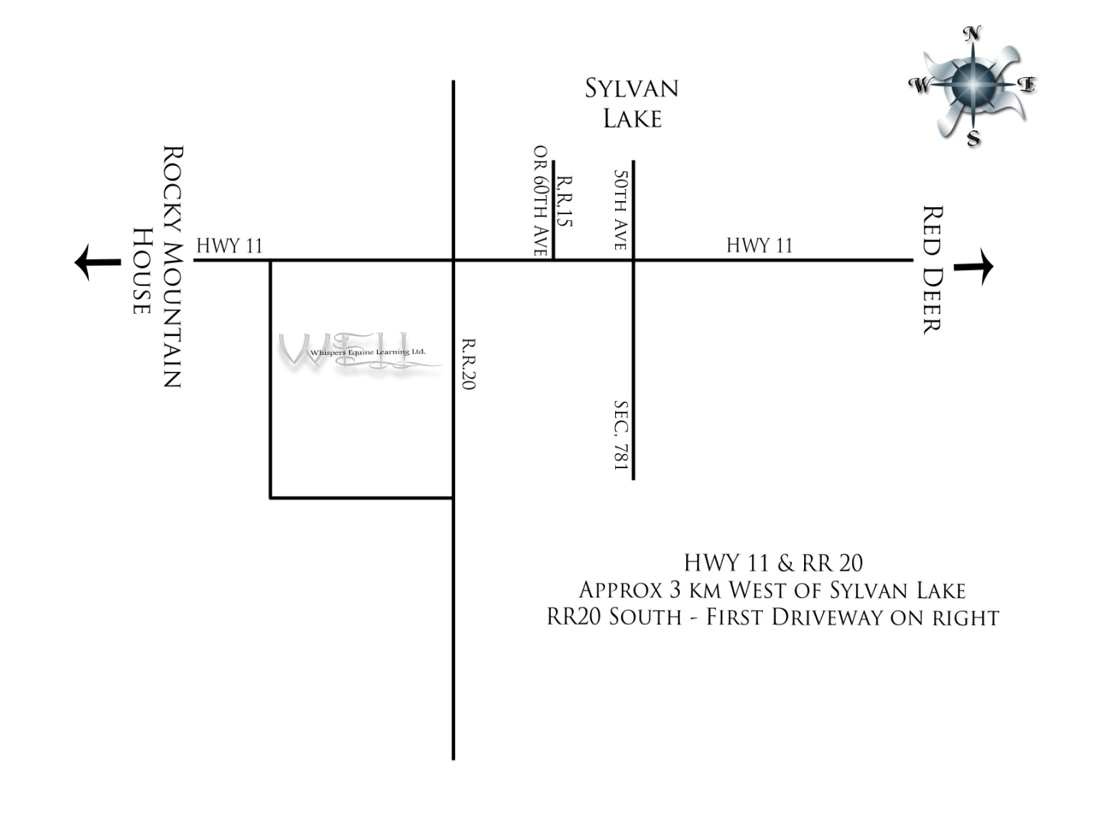

ROCKY MOUNTAIN HOUSE

38344 Range Rd 20

Red Deer County, AB

(403) 507-9619

Highway 11 & Rge Rd 20

Approx 2 miles West of Sylvan Lk

R.R. 20 South – First Driveway on Right

Hwy 11

CONFIDENT KIDS CANADA

Sec Hwy 781

Rge Rd 15

Rge Rd 20

SYLVAN LAKE

RED DEER